DATA DICTIONARY

ROCKBUSTER STEALTH LLC

KEVIN SOUSA

Table of Contents

**1. Entity Relationship Diagram (ERD)** ……………………………………….………………………………….…..…….2

**2. Fact Tables** ………………………………………………………………………………………………………………….….…..3

2.1 Payment Table ..………………………………………………………………………………………………..….3

2.2 Rental Table ………………………………………………………………………………………………………….3

**3. Dimension Tables** ………………………………………………………………………………………………….…..…..……4

3.1 Film_actor Table …………………………………………………………………………………………….…….4

3.2 Inventory Table ……………………………………………………………………………………………..……..4

3.3 Film_category Table ………………………………………………………………………………………….….4

3.4 Customer Table …………………………………………………………………………………………………….4

3.5Staff Table …………………………………………………………………………………………………………….5

3.6Actor Table ………………………………………………………………………………………………..………….5

3.7 Film Table ……………………………………………………………………………………………………………..5

3.8Category Table ………………………………………………………………………………………..…………….5

3.9 Language Table …………………………………………………………………………………………….……....6

3.10 Address Table ………………………………………………………………………………………………………6

3.11 City Table …………………………………………………………………………………………………………….6

3.12 Country Table ………………………………………………………………………………………………….....6

3.13 Store Table ……………………………………………………………………………………………………….…6

Entity Relationship Diagram

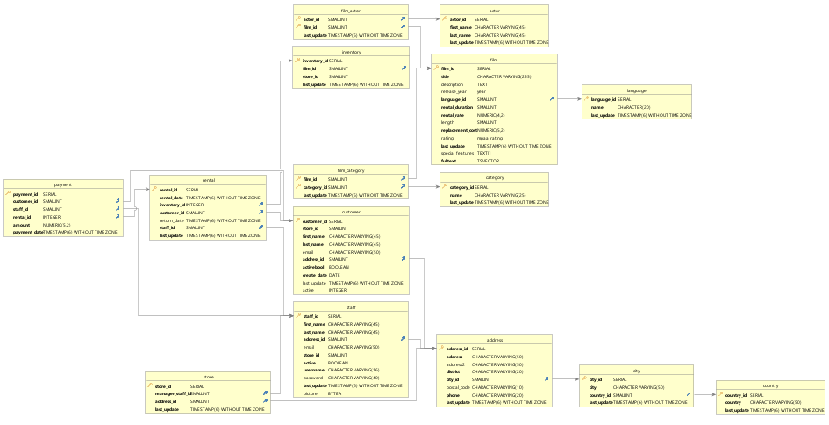

Fact Tables

**2.1 Payment Table**

|  |  |  |
| --- | --- | --- |
| **Column** | **Data Types** | **Description** |
| Payment_id | Serial | Identifies payment |
| Customer_id | Smallint | Identifies customer |
| staff_id | Smallint | Identifies staff |
| rental_id | Integer | Identifies rental |
| Amount | Numerics | Amount paid |
| Payment_date | Timestamp without timezone | When it was paid |

**2.2 Rental Table**

|  |  |  |
| --- | --- | --- |
| Rental_id | Serial | Identifies rental |
| Rental_date | Timestamp without timezone | When it was rented |
| inventory_id | Integer | Identifies inventory |
| customer_id | Smallint | Identifies customer |
| Return_date | Timestamp without timezone | Date it was returned |
| staff_id | Smallint | Identifies staff |
| Last_update | Timestamp without timezone | Date it was last updated |

Dimension Tables

**3.1 Film_actor Table**

|  |  |  |
| --- | --- | --- |
| **Column** | **Data Types** | **Description** |
| Actor_id | smallint | **Primary Key** Identifies actor |
| Film_id | Smallint | **Foreign Key** Identifies film |
| Last_update | Timestamp without timezone | Date it was last updated |

**3.2 Inventory Table**

|  |  |  |
| --- | --- | --- |
| Inventory_id | Serial | **Primary Key** Identifies inventory |
| Film_id | Smallint | **Foreign Key** Identifies film |
| Store_id | Smallint | **Foreign Key** Identifies Store |
| Last_update | Timestamp without timezone | Date it was last updated |

**3.3 Film_category Table**

|  |  |  |
| --- | --- | --- |
| Film_id | Smallint | **Primary Key** Identifies film |
| Category_id | Smallint | **Foreign Key** Identifies category |
| Last update | Timestamp without timezone | Date it was last updated |

**3.4 Customer Table**

|  |  |  |
| --- | --- | --- |
| Customer_id | Serial | **Primary Key** Identifies Customer |
| Store_id | Smallint | **Foreign Key** Identifies store |
| First_name | Character varying | Provides customer name |
| Last_name | Character varying | Provides customer name |
| Email | Character varying | Provides customer email |
| Address_id | Smallint | **Foreign Key** Provides customer address |
| Activebool | Boolean | Active customers (true/false) |
| Create_date | Date | Date record was created |
| Last_update | Timestamp without timezone | Date it was last updated |
| Active | Integer | Info if client is active or not |

**3.5 Staff Table**

|  |  |  |
| --- | --- | --- |
| staff_id | serial | **Primary Key** Identifies staff |
| First_name | Character varying | Provides customer name |
| Last_name | Character varying | Provides customer name |
| Address_id | Smallint | **Foreign Key** Provides customer address |
| Email | Character varying | Provides customer email |
| Store_id | Smallint | **Foreign Key** Identifies store |
| Active | Boolean | Info if staff is active or not |
| Username | Character varying | Staff username |
| Password | Character varying | Staff password |
| Last_update | Timestamp without timezone | Date it was last updated |
| Picture | BYTEA | Shows staff picture |

**3.6 Actor Table**

|  |  |  |
| --- | --- | --- |
| Actor_id | smallint | **Primary Key** Identifies actor |
| First_name | Character varying | Provides actor name |
| Last_name | Character varying | Provides actor name |
| Last_update | Timestamp without timezone | Date it was last updated |

**3.7 Film Table**

|  |  |  |
| --- | --- | --- |
| Film_id | serial | **Primary Key** Identifies film |
| Title | Character varying | Provides film title |
| Description | Text | Provides film description |
| Release_year | Year | Date film was released |
| Language_id | Smallint | **Foreign Key** What language is spoken |
| Rental_duration | Smallint | How long it was rented for |
| Rental_rate | Numeric(4,2) | How often its rented |
| Length | Smallint | How long the film is |
| Replacement cost | Numeric(5,2) | How much to replace film |
| Rating | Mpaa_rating | What the movie is rated |
| Last_update | Timestamp without timezone | Date it was last updated |
| Special features | Text[] | Features film contains |
| fulltext | tsvector | Full text index |

**3.8 Category Table**

|  |  |  |
| --- | --- | --- |
| Category_id | Smallint | **Primary Key** Identifies category |
| name | Character varying | Provides actor name |
| Last_update | Timestamp without timezone | Date it was last updated |

**3.9 Language Table**

|  |  |  |
| --- | --- | --- |
| Language_id | Serial | **Primary Key** Language spoken in film |
| Name | Character | Name of film |
| Last_update | Timestamp without timezone | Date it was last updated |

**3.10 Address Table**

|  |  |  |
| --- | --- | --- |
| Address_id | Serial | **Primary Key** Identifier for address |
| Address | Character varying | Address option |
| Address_2 | Character varying | Second address option |
| District | Character varying | Identifies district |
| City_id | Smallint | **Foreign Key** Identifies City |
| Postal_code | Character varying | Identifies postal code |
| Phone | Character varying | phone # |
| Last_update | Timestamp without timezone | Date it was last updated |

**3.11 City Table**

|  |  |  |
| --- | --- | --- |
| City_id | Serial | **Primary Key** Identifies city |
| City | Character varying | City name |
| Country_id | Smallint | **Foreign Key** identifies country |
| Last_update | Timestamp without timezone | Date it was last updated |

**3.12 Country Table**

|  |  |  |
| --- | --- | --- |
| Country_id | Serial | **Primary Key** Identifies country |
| Country | Character varying | Country name |
| Last_update | Timestamp without timezone | Date it was last updated |

**3.13 Store Table**

|  |  |  |
| --- | --- | --- |
| Store_id | Serial | **Primary Key** Identifies store |
| Manager_staff_id | Smallint | **Foreign Key** identifies manager |
| Address_id | Smallint | **Foreign Key** identifies store address |
| Last_update | Timestamp without timezone | Date it was last updated |